Báo cáo bài tập tuần 1

1.Hello World

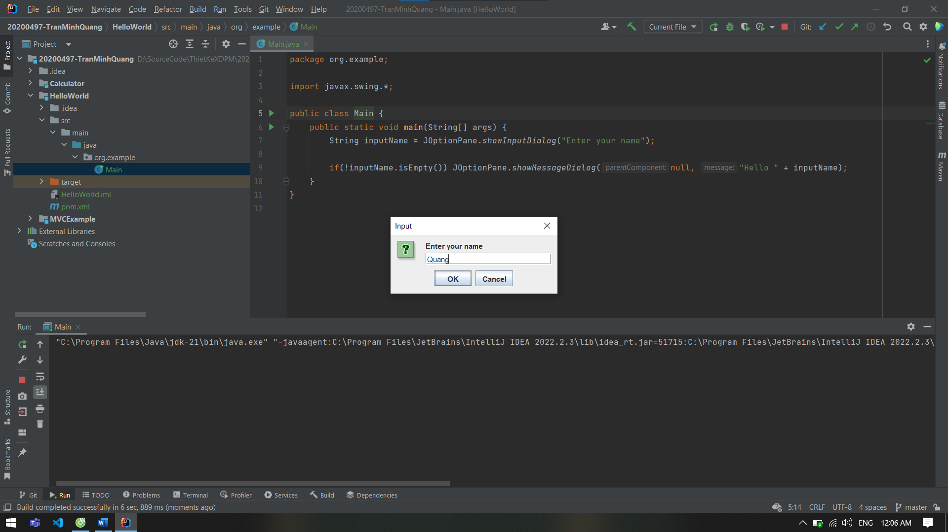

2.MVC example

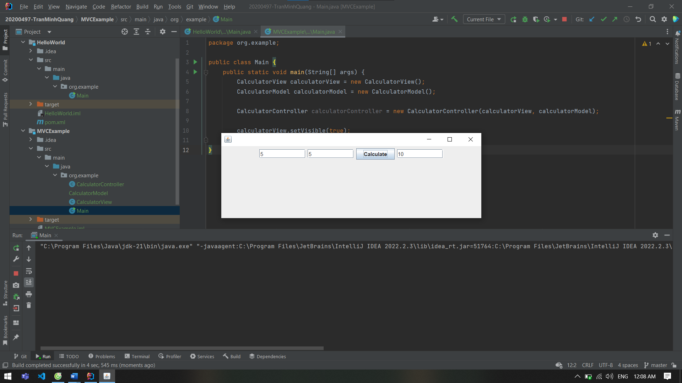

3.Calculator

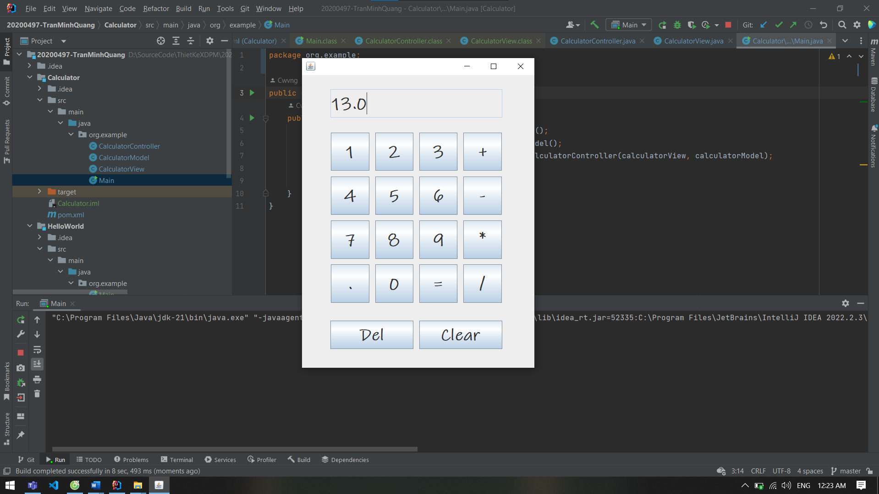

4.Git

-Modify file

-add and commit

-push

-create branch

-merge branch

